## 2.1 Introduction to Analysis

Analysis means detailed examination and investigation of the particular elements or structure of something typically as a basis for discussion or interpretation. Analysis is the process of breaking complex topic into smaller parts in order to get better output.

**Need of analysis**

We need to perform analysis because it helps us to quantify pattern and relationships in the data and display the results as maps, tables and charts. It also empowers us to answer questions and make important decisions using more than a visual analysis. The main objectives of analysis is to understand the requirement first and then to formalize it.

**PEST, SWOT, CATWOE Analysis**

**PEST (Political, Economic, Socio-cultural and Technological**) analysis is a simple and widely used tool that helps us to analyze the political, economic, socio-cultural and technological changes in our business environment. The effect of legal and environmental issues on a system can also be assessed using PEST. It helps us to understand strategic planning, develop a competitive analysis and markets, knowledge management and so on. the larger and more complex the organization or project, the more useful PEST can be as it can identify problems and issues.

**SWOT (Strength, Weakness, Opportunity and Threats)** analysis is a strategic planning method for gathering, structuring, presenting and reviewing data that specifies the aims of an organization and identifies the strength, weakness, opportunities and threats that are relevant to achieving the aims. SWOT provides a framework for reviewing the strategy, position and direction of a management system. It helps to focus activities into areas of strength and where the greatest opportunities lies and identifies dangers in the form of weaknesses and both internal and external threats.

**CATWOE (Customer/Client, Actor/Agent, Transformation, World view, Owner and Environment)** analysis is the part of Soft System Methodology which helps when defining a root definition. It helps to identify and categories all the people, processes and factors involved in the system that is being analyzed. In CATWOE analysis, the needs of the users need to be taken into account in order to enhance productivity and quality assurance. There are open discussion of problems, joint problem solving, user participation and commitments in CATWOE analysis. The term CATWOE refers to:-

* **Customer/Client**: - Customer/Client is the stakeholders those who are directly benefit and do not benefit from the work of an organization. They also suffer when there is change in the system. They are the real beneficiaries and consumer of the transformation. They need to be asked if they have problem with the existing system and how will they react to a new system and so on.
* **Actor/Agent**: - Actor or agents are directly involved to the implementation of the system. They are the type of stakeholders who are responsible for making the transformational activities. They are directly involved for solving the problems, finding new ideas and solutions.
* **Transformation**: - Transformation is the change that the system or process brings about. It refers to what happens to the data and what processes will be affected by development of the system. It is the third step of CATWOE where analyst needs to consider input, output and process of the system. it requires listing the inputs and the nature of change such inputs undergo to become outputs.
* **World view**: - Worldview is the justification for the transformation of the system or process. This refers to what is going on in and outside the organization and that may be influencing development of the system and gives the solution form different view for particular problem. This is also seen as the most crucial step in the CATWOE analysis where stakeholders often have different approaches to the same issue, with other interest.
* **Owner**: - owner refers to the entrepreneur or investor who owns the organization and has the authority to make changes. Owner is the type of stakeholder with the overall authority for the business system. Owner is the admin user of the project who has all the authorities like to start or stop the project, make changes to the project, future planning of the project or decide on whether to go ahead with the change. They are decision maker for the project.
* **Environment**: - Another important element of a CATWOE analysis is the external constraints under which the system works and which may hamper or restrict the changes to the system. Analyst needs to be aware of the demands of the political, legal, economic, social, demographic, technological, ethical, competitive, and environmental factors and their associated constraints and limitations. Environment is the rule and constraints surrounding the business system. It needs to be investigated whether this will affect the analysis and development of the system.

I have used CATWOE analysis in my project because CATWOE analysis is a system thinking tool of SSM to prepare comprehensive root definition models. It focuses on the existing system and processes that take place within an organization and entails studying how the features of elements within the system or process interact externally and internally. It gathers the perceptions of different stakeholders in a common platform and provides a holistic understanding that incorporates the different perspectives.

## 2.2 Feasibility Study

Feasibility study is an analysis or evaluation of the potential impact of a proposed project. It is a type of study which helps to examine and determine whether the project is technically, financially, socially, economically and legally feasible or not. It also helps us to determine whether our project is cost effective or not. It is one of the most important steps for software development process. The main importance of feasibility study is that it helps project planner to focus on the project and narrow down the possibilities. The main purpose of feasibility study is to whether the factor presented in a project makes a project success or not. We need feasibility study to determine the potential, problems, goals and solution of the existing system to determine which solution is easy for operational from the point of view of customer or employees such that it requires very less time with.

**Types of feasibility study:-**

1. **Economic feasibility: -** It is more commonly called as a cost benefit analysis which deals with the financial transaction of the management system. This involves the feasibility of the proposed project to generate economic benefits. The benefit cost analysis and a breakdown analysis are important aspects of evaluating the economic feasibility of new project. A system can be developed technically and effective to use if there is good investment. In my project, this feasibility study helps to evaluate the cost of my project whether the financial benefit is equal or exceed the cost.
2. **Technical feasibility: -** The technical feasibility accessesthe details of how you will deliver a product or service (i.e. materials, labor, transportation, where your business will be located, technology needed etc). The technical capability of the personnel as well as the capability of the available technology should be considered in technical feasibility. In my project, I have used this feasibility study to know whether the existing system is doing what is suggested or not and if the proposed equipment have the technical capacity to hold the data required to use the new system.
3. **Schedule feasibility: -** this feasibility study helps us to examine whether our project can be completed in the available time or not. This helps to estimate how long the system will take to develop. This process helps to access to which potential time frame and completion dates for all major activities within a project meet organizational deadlines and constraints for affecting change. This feasibility study helps my project by evaluating the time required to complete my project. It helps to manage the time and complete the project within given time frame.
4. **Operational feasibility: -** This feasibility system is dependent on the human resources available for the project. This measures how well our organization will be able to solve the problems and take advantage of opportunities that are presented during the course of the project. It reviews the willingness of the organization to support the proposed system. It determines if the human resources are available to operate the system once it has been installed. This feasibility study is about how well you solve the problems if system had investigation and crate solution. Proposed project is beneficial if it meets the organizational operating requirements. Some of the important factors it helps in my project includes:-

* **Is there sufficient support for the management from the users?**
* **Will there be any resistance from the user that will undermine possible application benefits?**

1. **Legal feasibility: -** Legal feasibility determines whether the proposed system conflicts with the legal requirements. It deals with the legal issues for the development of the system. If our development system is not fulfilling the government or organizational rules then this process helps to solve those problems. This feasibility study helps my project by considering legal issues and requirements whether it fulfills the government rules and regulations or not. It helps to solve the legal issues

which occur during the completion of my project.

## 2.3 Requirement Analysis

Requirement analysis is the process of defining the expectations of the user for an application that is to be built or modified. Requirement must be quantifiable, relevant and detailed. It is one of the important aspects of project management. It is the process of determining user expectations for a new or modified product. It helps to ensure that all stakeholders agree on what the system to be built as acquired is supposed to do. Requirement analysis is the team effort that demands a combination of hardware, software and human factors as well as skills in dealing with the people. The main objectives of requirement analysis are to arrive at a document that details all the requirement of the system, functional as well as non-functional.

**Functional Requirement**

Functional requirement are the product features or its function that must be designed directly for the users and their convenience. Functional Requirements include:

* Data input into the system
* Operation performed by the system
* Work flow of the system
* Data output from the system
* Who can enter the data into the system
* How the system meets the relevant requirements

Functional Requirements describes what the system should do. It involves calculations, technical details, data manipulation and processing and other specific functionality that define what a system is supposed to accomplish.

The functional requirements are:-

1. User Register
2. User login
3. Book Flights
4. User Logout
5. Ticket checking
6. Add, update and modify customer details
7. Review order

|  |  |
| --- | --- |
| **Functional Requirements ID** | **Title** |
| F1 | User login |
| F2 | User registration |
| F3 | Book flights |
| F4 | User Logout |
| F5 | Ticket checking |
| F6 | Add, Update and modify customer details |
| F7 | Review order |

**Non-Functional Requirement**

Non-functional requirements describe how the system works and performs a certain functions. It includes physical environments like equipments location, interfaces, user and human factors, performance, documentation, resources, security (backup, firewall) and quality assurance.

Non-functional requirement are the indirect helping features in the system which are:-

* **Reusability**: - reusability is the use of existing assets in some form within the software product development process as these assets are products and by products of the software development life cycle which includes code, software components, test suites, design and documentation.
* **Usability**: - Usability is the process of prioritization of the important functions based on the usage pattern. Frequently used functions should be tested for usability.
* **Performance**: - Performance is the part of non-functional requirement which includes performance of the application under undesirable conditions.
* **Security**: - Security means to safeguard the information and data, confidential or non-confidential data from external and internal security threats. Data should be transferred through secured protocols.
* **Maintainability**: - The system needs to be cost effective to maintain. So, maintainability requirements may cover diverse levels of documentation, such as system documentation as well as test documentation.
* **Scalability**: - this requirement helps to verify software behavior under both normal and anticipated peak load condition.

|  |  |
| --- | --- |
| **Non- functional requirements (ID)** | **Title** |
| NFR1 | Reusability |
| NFR2 | Usability |
| NFR3 | Performance |
| NFR4 | Security |
| NFR5 | Maintainability |
| NFR6 | Scalability |

**MoSCoW Prioritization**

Prioritization helps to set the goals and make our task more efficient and relevant. Prioritization allows right things to happen instead of less useful ones by determining a criterion estimate the criterion value for the task and sort the list based on the criterion value.

**MoSCoW prioritization**, also known as the MoSCoW method or MoSCoW analysis, is a popular prioritization technique for managing requirements. The method is commonly used to help key stakeholders understand the significance of initiatives in a specific release. The **MoSCoW** Method is an acronym made up of the first letters. The two Os have been added to make the word MoSCoW readable; they don't have any meaning themselves. The M stands for 'Must haves', S for 'should haves', C for 'could haves' and W for 'won't haves' where

**Must have: -** It defines a requirement that has to be satisfied for the final solutions to be acceptable**.** We cannot deliver a feasible solution without it.

**Should have:** - This is a high-priority requirement that should be included if possible.

**Could have:** - This is a desirable or nice to have requirement but the solution will still be accepted if the functionality is not included.

**Won’t have:** - This represents a requirement that stakeholders want to have but have agreed will not be implemented in the current version of the system.

Functional requirement:-

|  |  |  |
| --- | --- | --- |
| ID | Functional Requirement | Priority |
| FR1 | User login | Must have |
| FR2 | User registration | Must have |
| FR3 | Book flight | Should have |
| FR4 | User logout | Must have |
| FR5 | Ticket checking | Must have |
| FR6 | Add, delete and update | Must have |
| FR7 | Review order | Should have |
| FR8 | Internet | Must have |
| FR9 | Comment | Could have |
| FR10 | Online chat | Won’t have |

Non-functional requirement: -

|  |  |  |
| --- | --- | --- |
| **ID** | **Non-functional requirement** | **Priority** |
| NFR1 | Reusability | Should have |
| NFR2 | Usability | Should have |
| NFR3 | Performance | Should have |
| NFR4 | Security | Must have |
| NFR5 | Maintainability | Should have |
| NFR6 | scalability | Should have |
| NFR7 | Browser support | Must have |

**SRS**

SRS (Software Requirement Specification) is the contract between the development team and the customer. It is the fundamental document that bridges the gap between user requirement and developer view. It should address functionality, external interfaces, required performance, quality attribute and design constraints imposed on an implementation.

**Software Requirement**

**Programming language**: - PHP

**Database**: - MySQL

**UI Design**: - html, Ajax, jquery, JavaScript

**Web browser**: - Mozilla, Google chrome

**Software used**: - Xampp server

**Hardware requirement**

**Memory: -** 4GB RAM

**Storage: -** 1 GB

**OS**: - Windows 10 64bits

**Use case**

A use case is a methodology usedin system analysis to identify, clarify, and organize system requirements. The use caseis made up of a set of possible sequences of interactions between systems and users. It is a list of actions or event steps typically defining the interactions between a role and system to achieve goal. It defines the features to be implemented and the resolution of any errors that may be encountered.

Characteristics associated with the use case are:-

* Organizing functional requirements
* Modelling the goals of system user interactions
* Recording scenarios from trigger events to ultimate goals
* Describing the basic course of actions and expectational flow of events
* Permitting user to access the functionality of another event

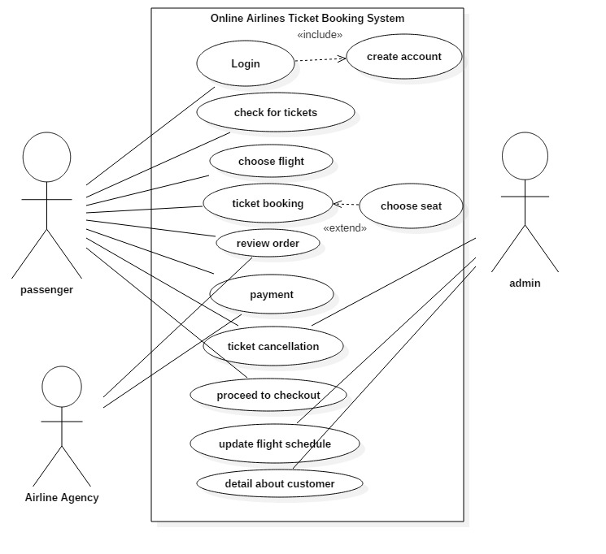

Fig.1:- Use case diagram

|  |  |
| --- | --- |
| Use Case | Description |
| Login | Login is used by passenger in order to authenticate a user. These consist of username and password. |
| Create Account | Account is created by passenger to login, book and check tickets. This the initial stage which is the important part of any system without which we cannot perform other task like login, booking etc. |
| Check for tickets | Passenger checks for the availability of the ticket. If there is availability of tickets then they will do reservation. |
| Choose flights | This task is performed by passenger where they choose appropriate and suitable flights. If it has flexibility in their schedule then they will choose flight and book tickets. |
| Ticket booking | After searching for the suitable flight and ticket, passenger will book ticket. After measuring airlines and travel sites for cheap flight, passenger will book ticket for their destination. |
| Choose seat | This task is performed by passenger and this is not mandatory also. After booking ticket, they will search for suitable seats. |
| Review order | Review order is done by both passenger and airline agency in order to see whether it can be improved or corrected. This task is done to provide their opinion. |
| Payment | Payment is done by both passenger and airline agency. Passenger will make payment to the system or airline agency. |
| Ticket cancellation | Cancellation of ticket is done by both passenger and admin during some circumstances. If there is any problem with the system or if passenger faced any problem then cancellation of ticket is done. |
| Proceed to checkout | After reviewing the flights and cost of ticket, passenger needs to be proceeding to checkout. |
| Update flight schedule | Flight schedule is updated by admin. Admin will update flight schedule in case of flight delayed and changes, changes in weather. |
| Detail about customer | Admin will keep detail about passenger through PNR (passenger name record) which is recorded in the computer reservation system. There is personal information about the passenger. |

**Initial Class Diagram**

**NLA**

|  |  |
| --- | --- |
| **NOUN** | **VERB** |
| Flight, name, code, destinations, timing, frequency, users, airports, seats, status, reservations, passengers, price, book, ticket, payment, mail, room, food, schedule, order, flight | Add, update, delete, modify, booking, detail, presenting, filling, cancellation, using, login, register, entering, providing, details, successful booking, visible, download |

**Candidate class (noun):** passenger, order, scheduledflight, travel agency

**Candidate class (verb**): login, register, add, update and delete, booking, details, and cancellation.

## 

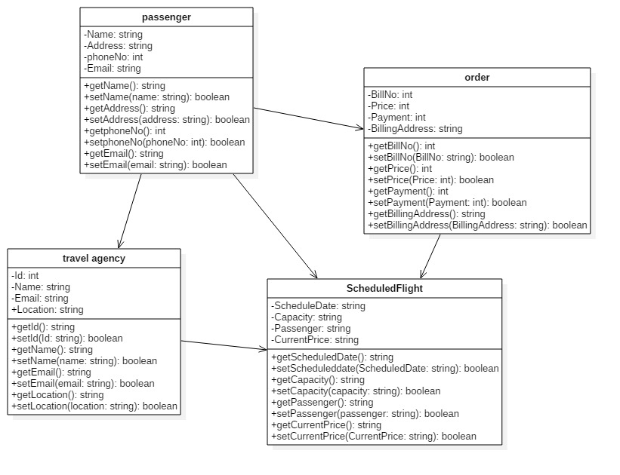

Fig.2:- class diagram

## Conclusion

As I have completed my analysis part by doing SWOT, PEST and CATWOE analysis and also doing feasibility study. I have chosen to apply CATWOE analysis in my project as it helps to gathers the perceptions of different stakeholders in a common platform and provides a holistic understanding that incorporates the different perspectives. I have performed feasibility study in order to know whether the project is technically, financially, socially, economically and legally feasible or not. I have figure out the functional and non functional requirements also. In my project, I have included use case diagram and class diagram by NLA.

## References

W. Kenton (2004), feasibility study, U.S, Investopedia

S. William (25th October, 2018), requirements blog, Stockholm Sweden, ReQtest

R. Robert (20015), difference between functional and non-functional, New Zealand, Guru99